

October 30, 2019

**Ian Gothe Premieres New "Spanish Caravan" Video**

**GP's got the exclusive on Gothe's debut single - a beautiful, deeply personal cover.**

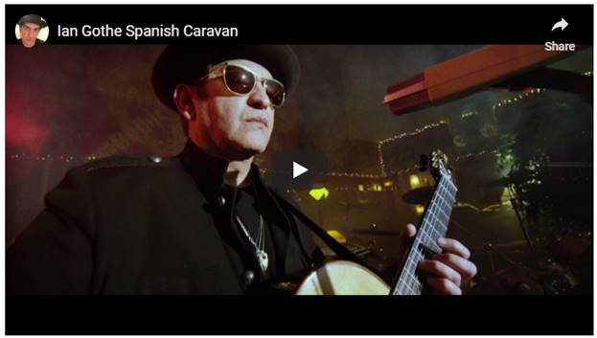

The road Ian Gothe took to get to his debut album, *Memento*, is a curious one - with the sort of twists and turns you don't tend to find in the one-sheets of most budding guitarists.

Born to an Armenian family in Iran, Gothe picked up the guitar as a teenager. In his early twenties, a song he composed - "Cleopatra" - even managed to climb its way to the top of the Italian charts. However, after failing to find similar success afterwards, Gothe largely set his guitar aside for two decades.

It was only after the dissolution of Gothe's marriage, and a chance encounter at an open mic, that Gothe decided to have a second go at music. Today, *GP*presents the exclusive premiere of the video for Gothe's debut single, a cover of The Doors' "Spanish Caravan."

So, with such a well of songwriting inspiration, why choose "Spanish Caravan" as your first-ever single? The answer, as it turns out, is a deeply personal one.

"When I was 12 years old, I was looking through my cousin's record collection and on the turntable there was a record," Gothe said. "I pressed play and what I heard totally mesmerized me, it was 'Spanish Caravan' by The Doors, the first track on side B. That’s when I said to myself, 'I want to learn to play the guitar.'"

*Memento* is set for a February 7 release via the Blackbird Record Label.

**For more on Gothe and his music, follow along on**[**Facebook**](https://www.facebook.com/iangotheofficial)**.**

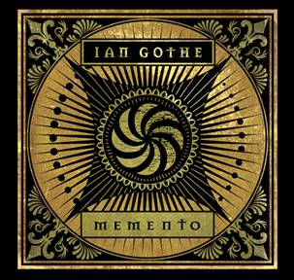

**Website**: <https://www.iangothe.com/>

**Facebook**: <https://www.facebook.com/iangotheofficial>

**Instagram:** <https://www.instagram.com/iangotheofficial/>

###